**GenAI**

**CA-II**

**Assignment**



**Name: Jayesh Ikhar**

**PRN: 21070521034**

**Section: A**

**Q: 1 Generate a model to represent a mathematical equation, write a program to parse the**

**Equation, and ask for input for each parameter.**

**Solution:** Flowchartto understand the flow of solution for the problem statement given.

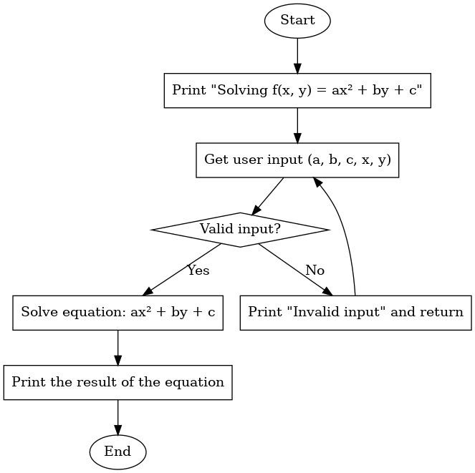

**Code:**

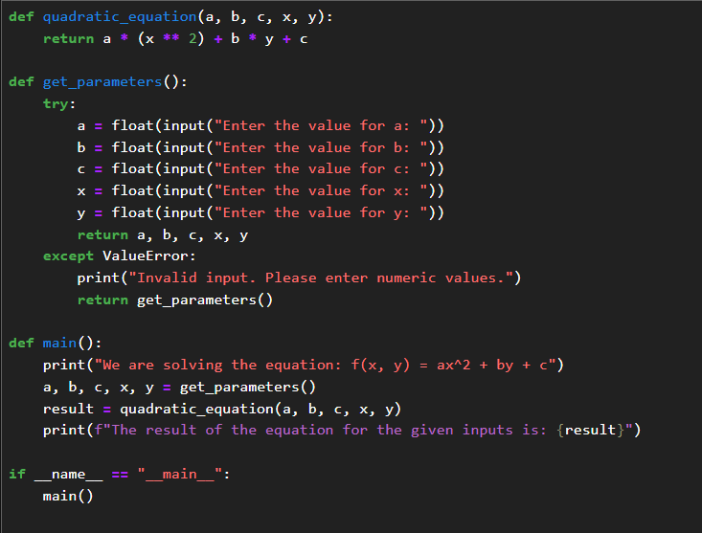

**Output:**

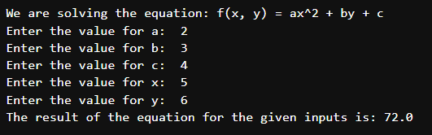

**Q: 2 Generate a model in Python to represent a Housing loan scheme and create a chart to**

**Display the Emi based on rate of interest and reducing balance for a given period. If a customer**

**Wishes to close the loan earlier, print the interest lost distributed over the remaining no. Of**

**Months. Assume suitable data and inputs as necessary.**

**Solution:** Flowchartto understand the flow of solution for the problem statement given.

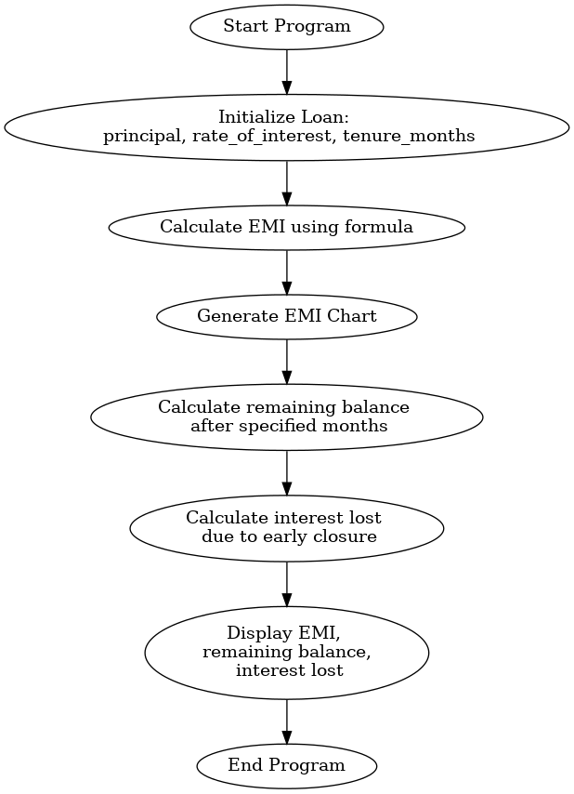

**Code:**

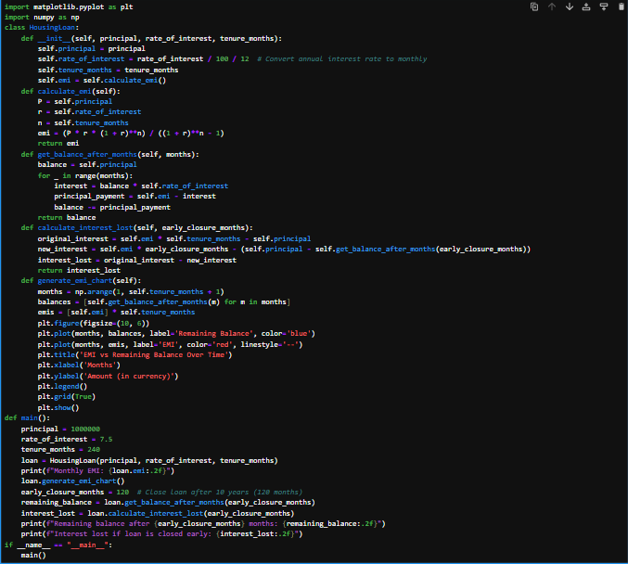

**Output:**

